Lesson: Grooming
Directions: Watch the included grooming video, and then complete the activity with your students.
There are three included activities with the lesson; please choose whichever activity you feel best suits your students’ needs. If you desire, you may use more than one activity.
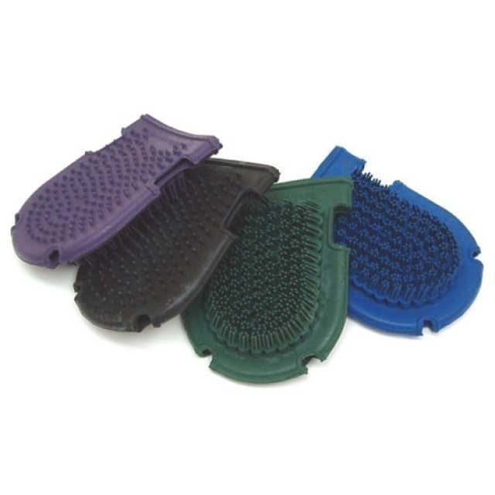
Here is a reference guide for the grooming tools:
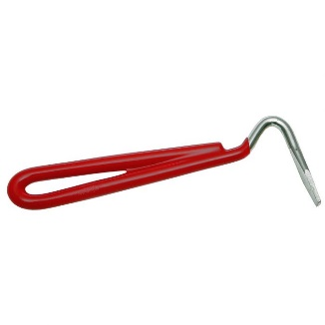
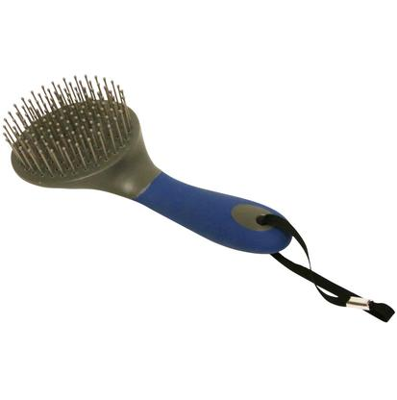
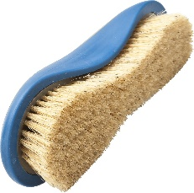
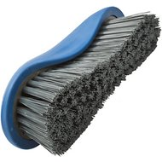
Curry Comb
Hoof-pick
Mane and Tail Brush
Hard Brush (Stiff Bristles)
Soft Brush (Soft Bristles)

